# CS 340 README Project 2 Dylan Ackron

## About the Project/Project Title

This project by Grazioso Salvare Is intended to assist the recruitment of dog breeds for certain types of rescue missions, such as water rescue, mountain rescue, and disaster and individual tracking. This project’s goal was to develop software that allowed us to gather information about animals at animal shelters and allowed us to compile a database with all the information gathered from these shelters. The program allows us to filter through this database to narrow down certain parameters, for instance each type of rescue mission may be better suited to dogs of specific breeds, and or ages. Knowing this, we were able to create filter types that narrowed down searches for these specific mission types.

## Motivation

The motivation behind the creation of this project was to make the efforts of being able to find reliable search and rescue dogs much easier for emergency personnel.

## Getting Started

To get this project running locally the first step would be creating a new user inside of the mongo shell for the AAC database, a user the has reading and writing access to the database. Next simply download both the python module and the python script. Next simply run the script in jupyter notebook. The script can be edited to create data dependent on the user.

## Installation

Current version of MongoDB

Current version of Python

CRUD .py file

.ipnyb file

## Usage

*Use this space to show useful examples of how your project works and how it can be used. Be sure to include examples of your code, tests, and screenshots.*

### Code Example

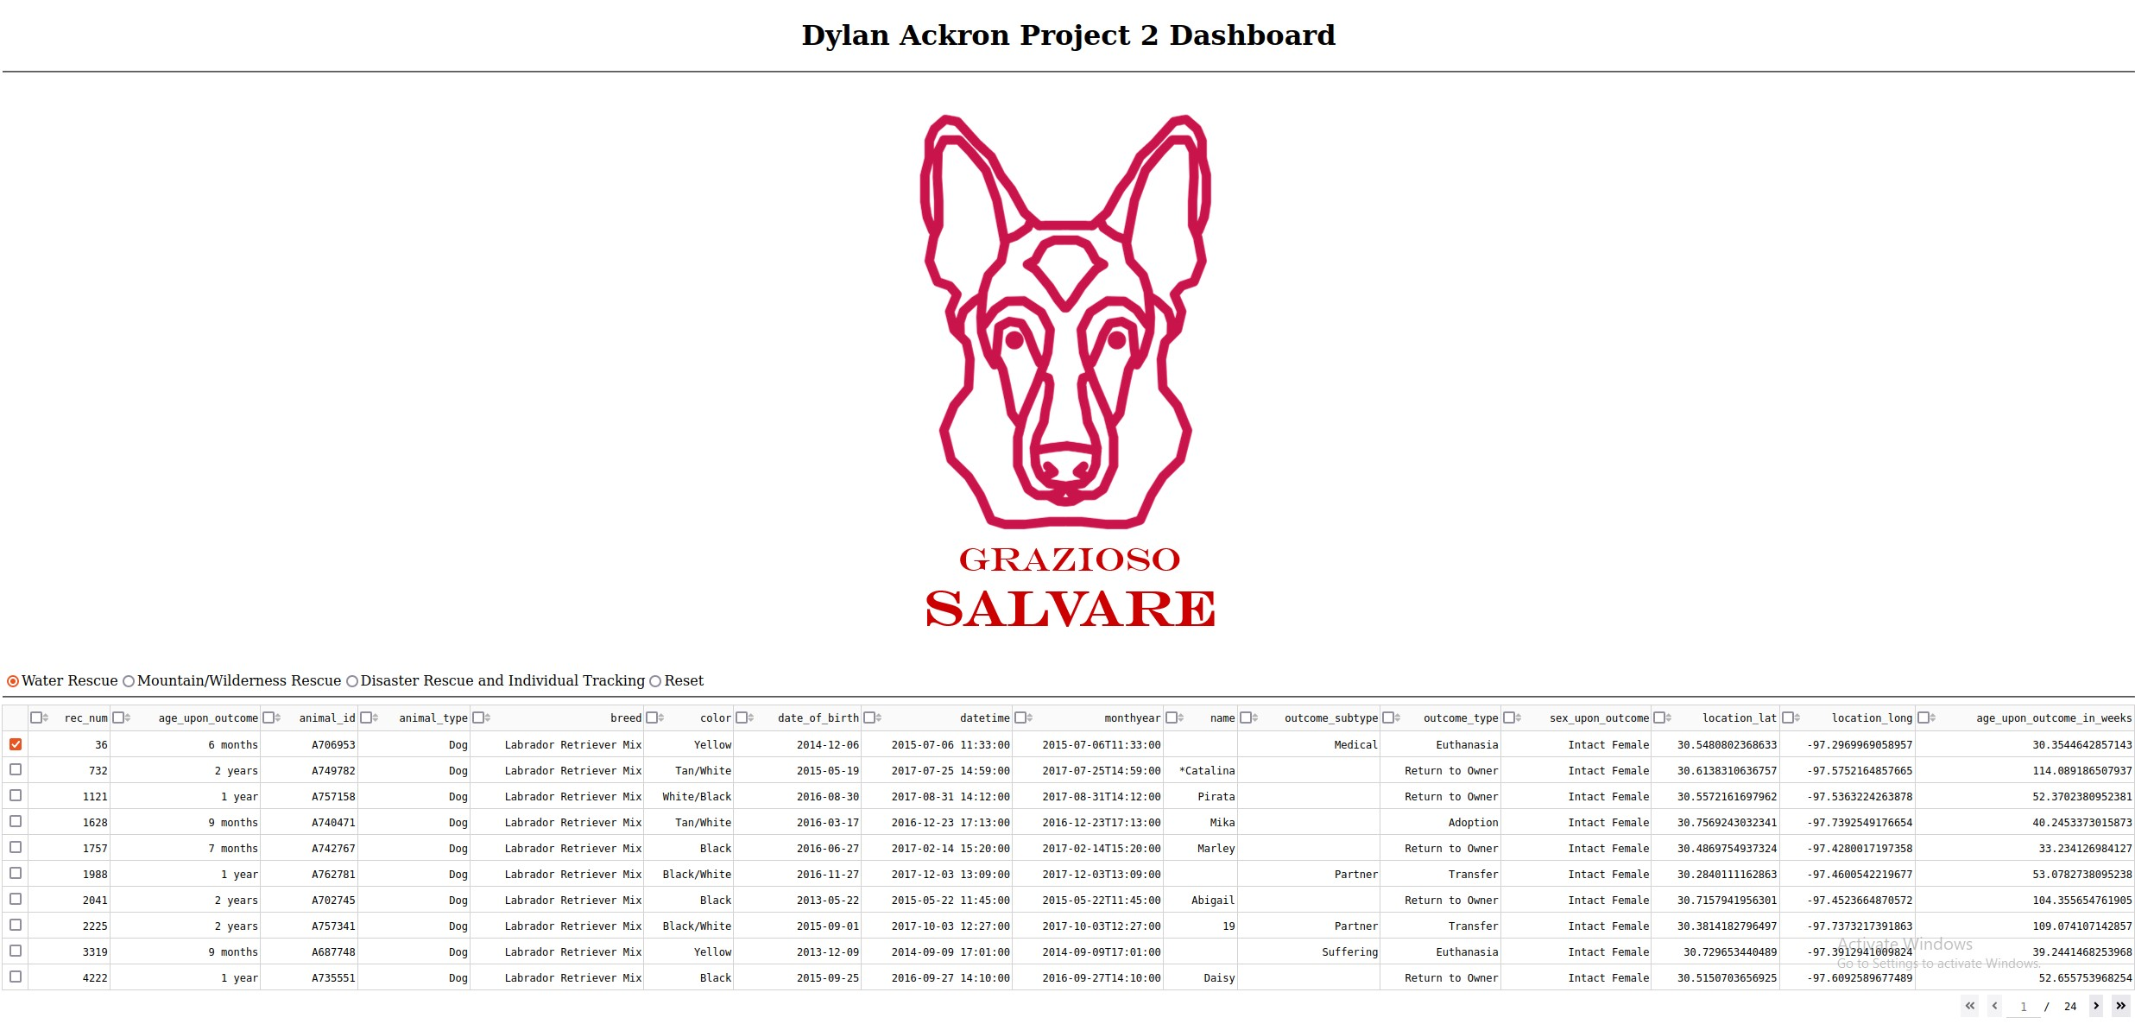

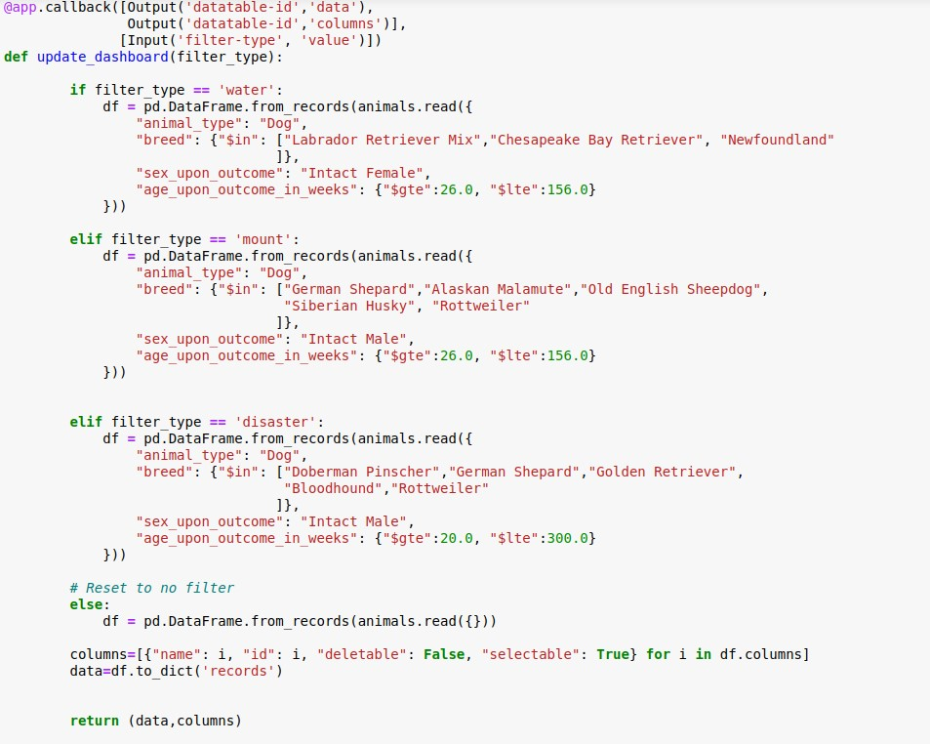This Code Example shows the different filters, each filter has different read parameters of the AAC database, so its able to search for exactly what's needed for that type of rescue mission.

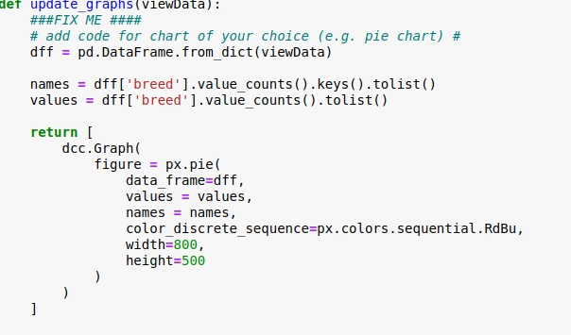  
This code example shows how the pie chart updates as you switch between pages, updating the percentage of the breeds on the current page.

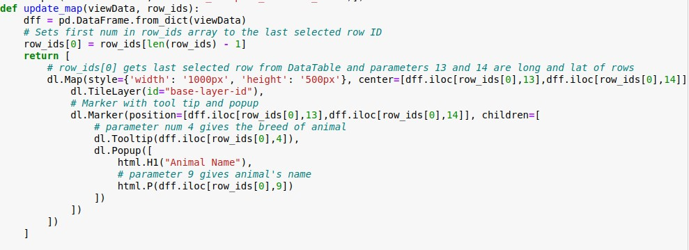

### This code example shows how the map updates based off of what item you select, each animal may have a different location, and when you click on an individual one, it will adjust the map based off of the rows coordinates.

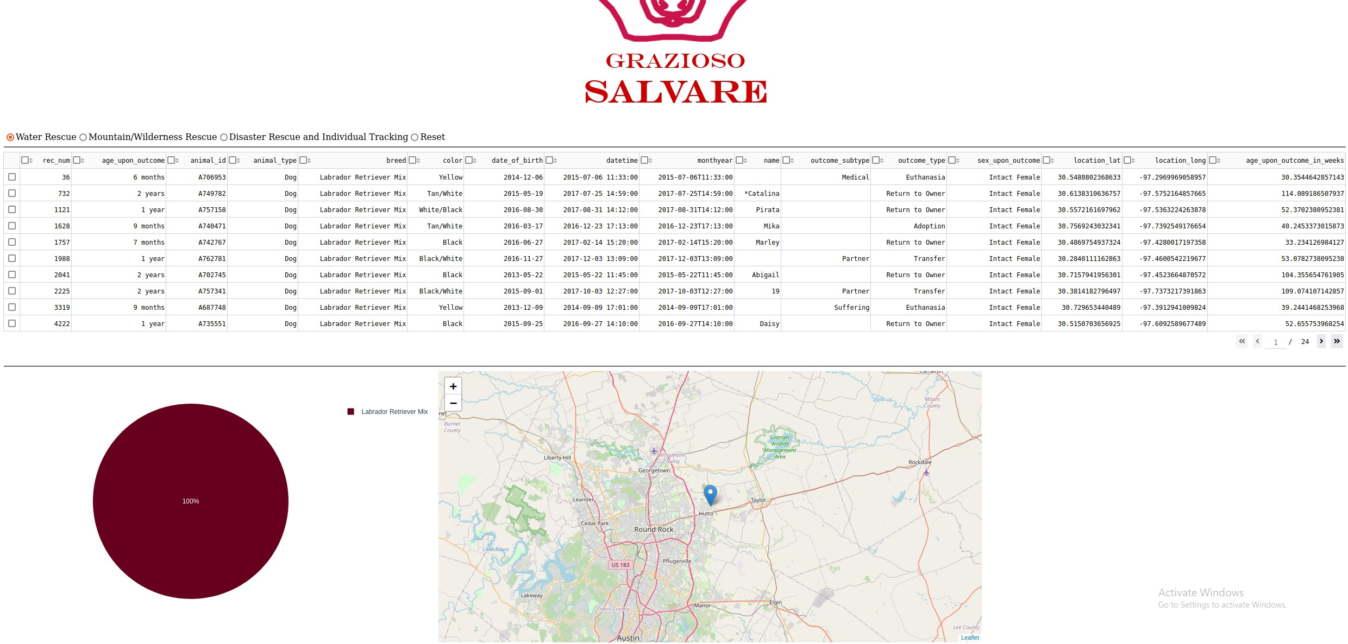

## This shows the table being filtered based off of water rescue missions, and the pie chart shows 100% Labrador retriever mix on this current page.

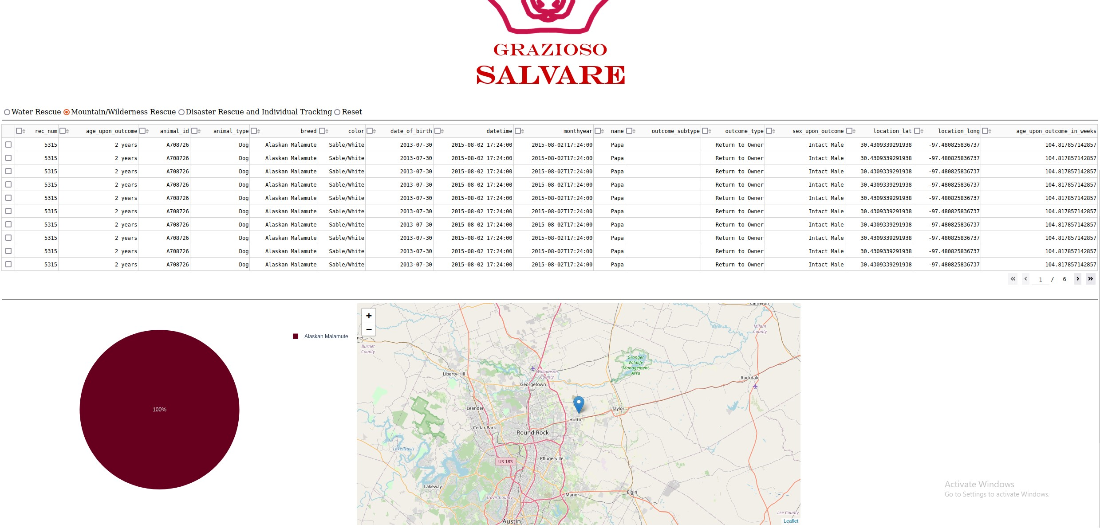This one shows the table being filtered for Mountain rescue

This one shows location moving from the previous test example, because a different animal was chosen, updating the location on the map.

## Contact

Your name: Dylan Ackron